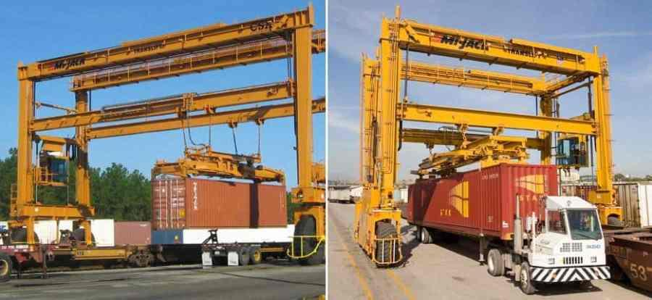
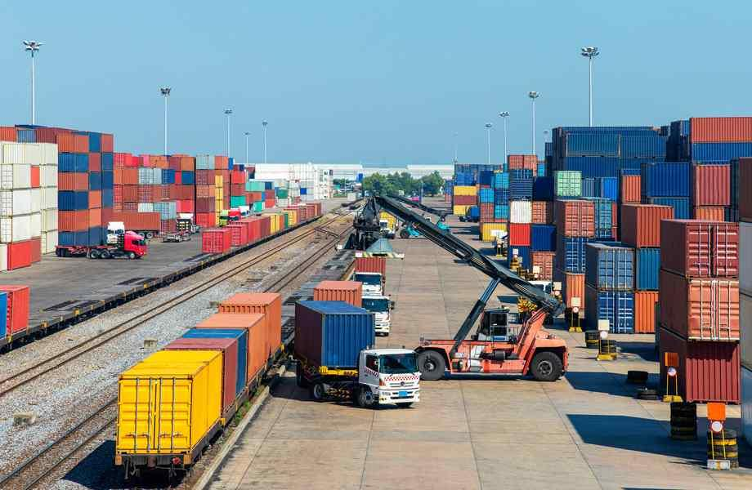

Model Curriculum

QP Name: Rail Logistics Executive

QP Code: LSC/Q5101

QP Version: 1.0

NSQF Level: 4.5

Model Curriculum Version: 1.0
Logistics Sector Skill Council||Logistics Sector Skill Council, No. 480 A, 7th floor Khivraj Complex 2, Anna Salai, Nandanam, Chennai – 600 035

Table of Contents
Training Parameters 2
Program Overview 3
Training Outcomes 3
Compulsory Modules 3
Module 1: Introduction to Rail Logistics Executive 5
Module 2: Management of Railway Freight Terminals 6
Module 4: Commercial Operations and Coordination 8
Module 5: Liabilities, Claims, Risk and Insurance 9
Module 6: Compliance for Safety Regulations 10
Module 8: Follow health, safety and security procedures at workplace. 12
Module 9: Employability Skills 13
Annexure 15
Trainer Requirements 15
Assessor Requirements 16
Assessment Strategy 17
References 19
Glossary 19
Acronyms and Abbreviations 20

Training Parameters
Sector | Logistics
Sub-Sector | Rail Logistics
Occupation | Container Train Operations (CTO), Private Freight Terminal Operations
Country | India
NSQF Level | 4.5
Aligned to NCO/ISCO/ISIC Code | NCO-2015/4323
Minimum Educational Qualiﬁcation and Experience | Completed 1st year of 3-year/ 4-years UG  OR  Pursuing 3rd year of 3-year diploma after 10th and continuing education  OR  Completed 3-year diploma after 10th  OR  Completed 1st year of 2 year diploma after 12th  OR  Pursuing 2nd year of 2- year diploma after 12th and continuing education  OR  12th Grade Pass + 1 year relevant experience
Pre-Requisite License or Training | NA
Minimum Job Entry Age | 21 years
Last Reviewed On | 30-11-2023
Next Review Date | 30-11-2026
NSQC Approval Date | 30-11-2023
QP Version | 1.0
Model Curriculum Creation Date | 30-11-2023
Model Curriculum Valid Up to Date | 30-11-2026
Model Curriculum Version | 1.0
Minimum Duration of the Course | 510
Maximum Duration of the Course | 510

Program Overview
This section summarizes the end objectives of the program along with its duration.

Training Outcomes
At the end of the program, the learner will be able to:
- Prepare a daily operations plan for any rail terminal depending on the layout and demand, using IT applications (FOIS).
- Oversee/Supervise/Coordinate all the activities related to day-to-day functioning and maintenance of the railway terminal.
- Manage the financial/commercial aspects to coordinate activities in a Rail Terminal.
- Take decisions in matters of disputes and grievances according to the provisions of the Railway Act, 1989 with respect to liabilities, claims, risks and insurance.
- Ensure compliance with health, safety and security procedures at the workplace.

Compulsory Modules
The table lists the modules, their duration and mode of delivery.
NOS and Module Details | Theory  Duration | Practical  Duration | On-the-Job Training Duration (Mandatory) | On-the-Job Training Duration (Recommended) | Total Duration
Bridge Module | 20 | 10 |  |  | 30
Module 1: Introduction to Rail Logistics Executive | 20 | 10 |  |  | 30
LSC/N5101 – Management of Railway Freight Terminals  V1.0  NSQF Level 4.5 | 20 | 65 | 5 |  | 90
Module 2: Management of Railway Freight Terminals | 20 | 65 | 5 |  | 90
LSC/N5102 – Overseeing the operations and general maintenance/upkeep of terminal  V1.0  NSQF Level 4.5 | 20 | 35 | 5 |  | 60
Module 3: Overseeing the Operations and general maintenance/upkeep of the terminal | 20 | 35 | 5 |  | 60
LSC/N5103 – Commercial Operations and Coordination  V1.0  NSQF Level 4.5 | 20 | 65 | 5 |  | 90
Module 4: Commercial Operations And Coordination | 20 | 65 | 5 |  | 90
LSC/N5104 – Liabilities, Claims, Risk and Insurance  V1.0  NSQF Level 4.5 | 20 | 35 | 5 |  | 60
Module 5: Liabilities, Claims, Risk and Insurance | 20 | 35 | 5 |  | 60
LSC/N5105 – Compliance for safety regulations  V1.0  NSQF Level 4.5 | 20 | 35 | 5 |  | 60
Module 6: Compliance For Safety Regulations | 20 | 35 | 5 |  | 60
LSC/N9908 – Maintain and monitor integrity and ethics in operations  V1.0  NSQF Level 4.5 | 15 | 15 |  |  | 30
Module 7: Maintain and monitor integrity and ethics in operations | 15 | 15 |  |  | 30
LSC/N9910: Follow health, safety and security procedures at workplace.  V1.0  NSQF Level 4.5 | 15 | 10 | 5 |  | 30
Module 8: Compliance to health, safety and security norms | 15 | 10 | 5 |  | 30
Employability Skills  DGT/VSQ/N0102 | 30 | 30 |  |  | 60
Module 9: Employability Skills | 30 | 30 |  |  | 60
Total Duration | 180 | 300 | 30 |  | 510

Module Details

Module 1: Introduction to Rail Logistics Executive
Mapped to Bridge Module
Terminal Outcomes:
- Describe the basic function of Rail Logistics
- Detail the various processes involved in Rail Logistics
Duration: 20:00 | Duration: 10:00
Theory – Key Learning Outcomes | Practical – Key Learning Outcomes
- Classify the components of logistics and supply chain  - Detail activities of Rail Logistics Executive  - Explain job roles in Rail Logistics  - Detail your job role as Rail Logistics Executive and its interface with other job roles | - Identify various activities in Rail Logistics  - Identify various job roles in Rail Logistics  - Identify the operations of various types of modes in Transportation (ex: Land, Air, Ocean, Multimodal, Rail etc)
Classroom Aids
Charts, Models, Video presentation, Flip Chart, Whiteboard/Smart Board, Marker, Board eraser
Tools, Equipment and Other Requirements
Computers with web camera, MS office, Scanner cum Printer

Module 2: Management of Railway Freight Terminals
Mapped to LSC/N5101, v1.0
Terminal Outcomes:
- Describe the monitoring of the intermodal functions
- Explain the use of IT (FOIS) for efficient communication, asset utilization, routing and scheduling
Duration: 20:00 | Duration: 65:00
Theory – Key Learning Outcomes | Practical – Key Learning Outcomes
- Discuss the preparation of plan for train formations and running staff duties.  - Describe the planning for maintenance and exigencies.  - Explain how to plan for quick loading/unloading to reduce turn- around time.  - Name the Cargo handling systems and double stack trains  - Elaborate the monitoring of freight train and yard activities on RMS and TMS  - Detail the responsibilities related to terminal on private land which is exclusively for its own cargo or common user facility or TMC or on MCA | - Identify the demand, number of train exchange on the basis of layout of the terminal.  - Demonstrate the attaching/detaching process of engines, bogies and wagons.  - Perform assembling, sorting and breaking of freight trains  - Solve day to day operational exigencies and quick redressal of issues  - Schedule for the maintenance and upkeep of the terminal dependent on the terms and conditions.
Classroom Aids
Charts, Models, Video presentation, Flip Chart, Whiteboard/Smart Board, Marker, Board eraser
Tools, Equipment and Other Requirements
TMS

Module 3: Overseeing the operations and general maintenance/upkeep of terminal
Mapped to LSC/N5102, v1.0

Terminal Outcomes:
- Coordinate with the rake maintenance team for placement on line
- Oversee intermodal operations
Duration: 20:00 | Duration: 35:00
Theory – Key Learning Outcomes | Practical – Key Learning Outcomes
- Create a maintenance checklist for smooth operations of the terminals at hand ensuring least lead time for cargo in transit, to reduce costs  - Ensure smooth access of trucks, transfer of containers and custom clearance at bonded warehouses  - Explain how to provide facility for servicing and repair of containers and equipment  - Discuss how to update cargo status and inspection report of wagons online on FOIS for single window clearance  - Detail the technical specifications of the equipment and assets as well as policies related to the terminal | - Examine the day to day working by coordinating with different modes for proper un- loading, storage, loading and dispatch of cargo  - Plan for conversion or expansion of the existing terminal facility  - Ensure smooth rail linkages to a factory, quarry, or warehouse with the siding.  - Coordinate with Rake maintenance team to ensure engine-on-load operations  - Provide basic amenities such as clean drinking water, rest areas, parking bays, loading platforms, marshalling, staging and storing for smooth intermodal operations
Classroom Aids
Charts, Models, Video presentation, Flip Chart, Whiteboard/Smart Board, Marker, Board eraser
Tools, Equipment and Other Requirements
LLMS, Worksheet software, Scanner cum Printer

Module 4: Commercial Operations and Coordination
Mapped to LSC/N5103, v1.0
Terminal Outcomes:
- Discuss the management & coordination with various commercial departments at Board, Zonal and Divisional levels
- Perform all commercial functions relating to passenger business
Duration: 20:00 | Duration: 65:00
Theory – Key Learning Outcomes | Practical – Key Learning Outcomes
- Explain how to coordinate with additional member commercial (for rate and claims), additional member catering (for marketing) and additional member looking into computerization for I-ticketing, E-ticketing, E-booking, as well as chief commercial manager for resolving issues related to rates, claims and other grievances at the zonal level  - Detail the process of issuing the Railway Receipt and eT-TRR  - Describe how to coordinate effectively with Logistics division, shipping lines, container train operators, exporters, Ministry of Commerce & Consumer Affairs and Public Distribution  - Discuss the PFT Policy, Own Your Wagon scheme, groups, divisions and classes of commodities. | - Demonstrate how to coordinate on a daily basis with supervisors dealing with goods, parcels, catering and reservations.  - Calculate train load rates from the base class  - Inspect the working of booking clerks and enquiry/reservation officers.  - Plan to install ‘universal terminals’ for self printing ticket machines (SPTMs)  - Plan for a ‘train load’ or consignment based on weight and charges applicable  - Prepare the loading/unloading pattern so as to minimize loss and damage of cargo  - Facilitate the movement of empty rakes, flats and containers  - Perform assessment and regular analysis of demand to augment trains as per requirement
Classroom Aids
Charts, Models, Video presentation, Flip Chart, Whiteboard/Smart Board, Marker, Board eraser
Tools, Equipment and Other Requirements
LLMS, Worksheet software, Scanner cum Printer

Module 5: Liabilities, Claims, Risk and Insurance
Mapped to LSC/N5104, v1.0

Terminal Outcomes:
- Discuss the compensations to be paid in accordance with the liabilities borne by the Railways
- Explain the disbursement of claims for freight

Duration: 20:00 | Duration: 35:00
Theory – Key Learning Outcomes | Practical – Key Learning Outcomes
- Explain how to assess compensation to be paid in case of loss, damage, or destruction of any consignment  - Describe the Bailey’s liability during termination of transit of consignment  - Define the process of e-filing of claims  - Discuss the liabilities and scheduling meetings with Railway Claims Tribunal | - Facilitate quick payment of compensation to customers  - Identify methods for quickly restoring normalcy in case of incidents such that there is least impact to environment, political and cultural areas  - Prepare a detailed step by step methodology for risk mitigation and train a team of juniors to address problems of customers and contractors in the carriage of goods.  - Evaluate the work of the staff, servicing each train as it arrives at the terminal  - Inspect the terminal to identify risk areas and plan for repair and maintenance
Classroom Aids
Charts, Models, Video presentation, Flip Chart, Whiteboard/Smart Board, Marker, Board eraser
Tools, Equipment and Other Requirements
LLMS, Worksheet software, Scanner cum Printer

Module 6: Compliance for Safety Regulations
Mapped to LSC/N5105, v1.0
Terminal Outcomes:
- Follow health, safety and security procedures
- Comply with health and safety regulations at workplace

Duration: 20:00 | Duration: 35:00
Theory – Key Learning Outcomes | Practical – Key Learning Outcomes
- Discuss the safety processes of Indian Railways as applicable to the area of his operation  - Create a checklist of regular inspection of carriageway, rolling stock & manpower of IR  - List the types of safety & security signage and their functions  - Read the Railway Act, Safe Working Rules, Commission of Railway Safety and Safety initiatives of IR | - Follow the protocol that are necessary to prevent common accidents and breach of safety  - Follow necessary SOP and precautions while handling dangerous cargo in the area and instruct handlers to follow procedures  - Arrange for regular inspections of MHE and other emergency equipments such as fire alarms, water sprinklers, smoke detectors, etc  - Organize regular fire drills in the terminal  - Report any violations in case of security checks of cargo- packaging, loading/unloading, weight or mis-declaration of cargo  - Identify unsafe conditions and report it to the Safety department
Classroom Aids
Charts, Models, Video presentation, Flip Chart, Whiteboard/Smart Board, Marker, Board eraser
Tools, Equipment and Other Requirements
First Aid Kit and Equipment used in Medical Emergencies, Personal Protective Equipment

Module 7: Maintain and monitor integrity and ethics in operations
Mapped to LSC/N9908, v1.0
Terminal Outcomes:
- Explain the concepts of integrity, ethics
- Detail the various regulatory requirements related to logistics industry
Duration: 15:00 | Duration: 15:00
Theory – Key Learning Outcomes | Practical – Key Learning Outcomes
- Describe the concepts of integrity, ethics  - Detail the various regulatory requirements related to logistics industry  - Explain data and information security practices  - Discuss the various corrupt practices  - Discuss regulatory requirements, code of conduct and etiquettes  - Detail the procedure for documenting all integrity and ethics violations  - Explain escalation matrix for reporting deviation | - Illustrate the importance of integrity and how ethics needs to be followed.  - Practice the principles of integrity and ethics  - Follow the various regulatory requirements related to logistics industry  - Perform data and information security practices  - Identify corrupt practices  - Comply to regulatory requirements  - Practice code of conduct and etiquettes  - Demonstrate what are the integrity and ethic violations.  - Document all integrity and ethics violations  - Report deviation as per the escalation matrix
Classroom Aids
Charts, Models, Video presentation, Flip Chart, Whiteboard/Smart Board, Marker, Board eraser
Tools, Equipment and Other Requirements
LLMS, Worksheet software, Scanner cum Printer, Personal Protective Equipment, Computers with web camera, Hygiene Equipment and Materials like Sanitizer, Soap, Mask etc

Module 8: Follow health, safety and security procedures at workplace.

Mapped to LSC/N9910, v1.0

Terminal Outcomes:
• Describe the application of health and safety practices at the workplace.
Duration: 15:00 | Duration: 10:00
Theory – Key Learning Outcomes | Practical – Key Learning Outcomes
- Describe personal hygiene practices.  - List first aid box items and their use  - List the situation that may lead to accidents at the workplace and ways to prevent them.  - Discuss data safety process and procedures to be followed at workplace.  - Describe the steps of emergency procedures during accidents/fire or other hazards situations.  - Identify safety signs.  - Classify the various fire extinguishers for different types of fires. | - Demonstrate personal hygiene practices to be followed at workplace.  - Demonstrate appropriate first aid in different situations.  - Practice emergency evacuation drills.  - Demonstrate the use of fire extinguishers.  - Illustrate how to maintain a clean workstation.
Classroom Aids
Charts, Models, Video presentation, Flip Chart, Whiteboard/Smart Board, Marker, Board eraser
Tools, Equipment and Other Requirements
Personal Protective Equipment (PPE), First Aid Kit and Equipment used in Medical Emergencies

Module 9: Employability Skills
Mapped to DGT/VSQ/N0102, v1.0
Terminal Outcomes:
- Discuss the Employability Skills required for jobs in various industries
- Explain the constitutional values, including civic rights and duties, citizenship, responsibility towards society and personal values and ethics such as honesty, integrity, caring and respecting others that are required to become a responsible citizen
- Discuss how to identify opportunities for potential business, sources of funding and associated financial and legal risks with its mitigation plan

Duration: 30:00 | Duration: 30:00
Theory – Key Learning Outcomes | Practical – Key Learning Outcomes
- Discuss the Employability Skills required for jobs in various industries  - List different learning and employability related GOI and private portals and their usage  - Explain the constitutional values, including civic rights and duties, citizenship, responsibility towards society and personal values and ethics such as honesty, integrity, caring and respecting others that are required to become a responsible citizen  - Discuss importance of relevant 21st century skills.  - Describe the benefits of continuous learning.  - Explain the importance of active listening for effective communication  - Discuss the significance of working collaboratively with others in a team  - Discuss the significance of escalating sexual harassment issues as per POSH act.  - List the common components of salary and compute income, expenditure, taxes, investments etc.  - Discuss the legal rights, laws, and aids  - Describe the role of digital technology in today’s life  - Discuss the significance of displaying responsible online behaviour while browsing, using various social media platforms, e-mails, etc., safely and securely  - Explain the types of entrepreneurship and enterprises  - Discuss how to identify opportunities for potential business, sources of funding and associated financial and legal risks with its mitigation plan  - Describe the 4Ps of Marketing-Product, Price, Place and Promotion and apply them as per requirement  - Detail the significance of analysing different types and needs of customers  - Explain the significance of identifying customer needs and responding to them in a professional manner.  - Discuss the significance of maintaining hygiene and dressing appropriately  - Explain the significance of maintaining hygiene and confidence during an interview  - List the steps for searching and registering for apprenticeship opportunities | - Practice different environmentally sustainable practices.  - Exhibit 21st century skills like Self-Awareness, Behaviour Skills, time management, critical and adaptive thinking, problem-solving, creative thinking, social and cultural awareness, emotional awareness, learning to learn etc. in personal or professional life.  - Demonstrate to use basic English sentences for everyday conversation in different contexts, in person and over the telephone  - Read and interpret text written in basic English  - Write a short note/paragraph / letter/e -mail using basic English  - Create a career development plan with well-defined short- and long-term goals  - Communicate effectively using verbal and nonverbal communication etiquette.  - Demonstrate how to behave, communicate, and conduct oneself appropriately with all genders and PwD  - Outline the importance of selecting the right financial institution, product, and service  - Demonstrate how to carry out offline and online financial transactions, safely and securely  - Operate digital devices and use the associated applications and features, safely and securely  - Create sample word documents, excel sheets and presentations using basic features  - Utilize virtual collaboration tools to work effectively  - Devise a sample business plan, for the selected business opportunity  - Create a professional Curriculum Vitae (CV)  - Use various offline and online job search sources such as employment exchanges, recruitment agencies, and job portals respectively  - Perform a mock interview
Classroom Aids
Charts, Models, Video presentation, Flip Chart, Whiteboard/Smart Board, Marker, Board eraser, UPS, LCD Projector, Computer Tables & chairs
Tools, Equipment and Other Requirements
Computer (PC) with latest configurations – and Internet connection with standard operating system and standard word processor and worksheet software (Licensed) (all software should either be latest version or one/two version below), Scanner cum Printer

Annexure

Trainer Requirements

Trainer Prerequisites
Minimum Educational Qualification | Specialization | Relevant Industry Experience |  | Training/Assessment Experience |  | Remarks
 |  | Years | Specialization | Years | Specialization
Any degree | Rail Logistics | 2 | Rail Logistics

Trainer Certification
Domain Certification | Platform Certification
Certified for Job Role: “Rail Logistics Executive” mapped to QP: “LSC/Q5101, V1.0”. Minimum accepted score is 80% | Recommended that the Trainer is certified for the Job Role: “Trainer (VET and Skills)”, mapped to the Qualification Pack: “MEP/Q2601, V2.0”. Minimum accepted score is 80%

Assessor Requirements

Assessor Prerequisites
Minimum Educational Qualification | Specialization | Relevant Industry Experience |  | Training/Assessment Experience |  | Remarks
 |  | Years | Specialization | Years | Specialization
Any degree | Rail Logistics | 2 | Rail Logistics

Assessor Certification
Domain Certification | Platform Certification
Certified for Job Role: “Rail Logistics Executive” mapped to QP: “LSC/Q5101, V1.0”. Minimum accepted score is 80% | Recommended that the Assessor is certified for the Job Role: “Assessor (VET and Skills)”, mapped to the Qualification Pack: “MEP/Q2701, V2.0” with Minimum score of 80%

Assessment Strategy
The emphasis is on ‘learning-by-doing' and practical demonstration of skills and knowledge based on the performance criteria. Accordingly, assessment criteria for each job role is set and made available in qualification pack.
The assessment papers for both theory and practical would be developed by Subject Matter Experts (SME) hired by Logistics Sector Skill Council or with the LSC accredited Assessment Agency as per the assessment criteria mentioned in the Qualification Pack. The assessments papers would also be checked for the various outcome-based parameters such as quality, time taken, precision, tools & equipment requirement etc.
Each NOS in the Qualification Pack (QP) is assigned a relative weightage for assessment based on the criticality of the NOS. Therein each Element/Performance Criteria in the NOS is assigned marks on relative importance, criticality of function and training infrastructure.
The following tools would be used for final assessment:
- Practical Assessment: This comprises of a creation of mock environment in the skill lab which is equipped with all equipment required for the qualification pack.

Candidate's soft skills, communication, aptitude, safety consciousness, quality consciousness etc. is ascertained by observation and marked in observation checklist. The outcome is measured against the specified dimensions and standards to gauge the level of their skill achievements.

- Viva/Structured Interview: This tool is used to assess the conceptual understanding and the behavioural aspects with regard to the job role and the specific task at hand. It also includes questions on safety, quality, environment, and equipment etc.

- On-Job Training: OJT would be evaluated based on standard log book capturing departments worked on, key observations of learner, feedback and remarks of supervisor or mentor.

- Written Test: Question paper consisting of 100 MCQs (Hard:40, Medium:30 and Easy: 30) with questions from each element of each NOS. The written assessment paper is comprised of following types of questions:

  - True / False Statements
  - Multiple Choice Questions
  - Matching Type Questions
  - Fill in the blanks
  - Scenario based Questions
  - Identification Questions

QA Regarding Assessors:
Assessors are selected as per the “eligibility criteria” laid down by LSC for assessing each job role. The assessors selected by Assessment Agencies are scrutinized and made to undergo training and introduction to LSC Assessment Framework, competency-based assessments, assessors guide etc. LSC conducts “Training of Assessors” program from time to time for each job role and sensitize assessors regarding assessment process and strategy which is outlined on following mandatory parameters:

    - Guidance regarding NSQF
    - Qualification Pack Structure
    - Guidance for the assessor to conduct theory, practical and viva assessments
    - Guidance for trainees to be given by assessor before the start of the assessments.
    - Guidance on assessments process, practical brief with steps of operations practical observation checklist and mark sheet
    - Viva guidance for uniformity and consistency across the batch.
    - Mock assessments
    - Sample question paper and practical demonstration

References

Glossary

Term | Description
Declarative Knowledge | Declarative knowledge refers to facts, concepts and principles that need to be known and/or understood in order to accomplish a task or to solve a problem.
Key Learning Outcome | Key learning outcome is the statement of what a learner needs to know, understand and be able to do in order to achieve the terminal outcomes. A set of key learning outcomes will make up the training outcomes. Training outcome is specified in terms of knowledge, understanding (theory) and skills (practical application).
OJT (M) | On-the-job training (Mandatory); trainees are mandated to complete specified hours of training on site
OJT (R) | On-the-job training (Recommended); trainees are recommended the specified hours of training on site
Procedural Knowledge | Procedural knowledge addresses how to do something, or how to perform a task. It is the ability to work, or produce a tangible work output by applying cognitive, affective or psychomotor skills.
Training Outcome | Training outcome is a statement of what a learner will know, understand and be able to do upon the completion of the training.
Terminal Outcome | Terminal outcome is a statement of what a learner will know, understand and be able to do upon the completion of a module. A set of terminal outcomes help to achieve the training outcome.

Acronyms and Abbreviations

Term | Description
QP | Qualification Pack
NSQF | National Skills Qualification Framework
NSQC | National Skills Qualification Committee
NOS | National Occupational Standards

